Guerrilla Test Report:
Comic Stock Phase 1
Date: 07 April 2026 Location: Entelect
Product: Checkout – Comic Stock Version: 1
GOAL
What we wanted to ascertain out of this investigation is to design a functional mobile checkout interface for Comic Stock, a startup business aiming to occupy South Africa’s premier position as an online comic book retailer.
Comic Stock stipulated the payment/checkout process to be “easy”, “intuitive”, and “frictionless”. Below is our original paper mock-up design.
In following our principles for design, we wanted to make sure that we empathise with the end users as soon as possible by collecting information about their user experience with our proposed solutioning.
Page 1-2
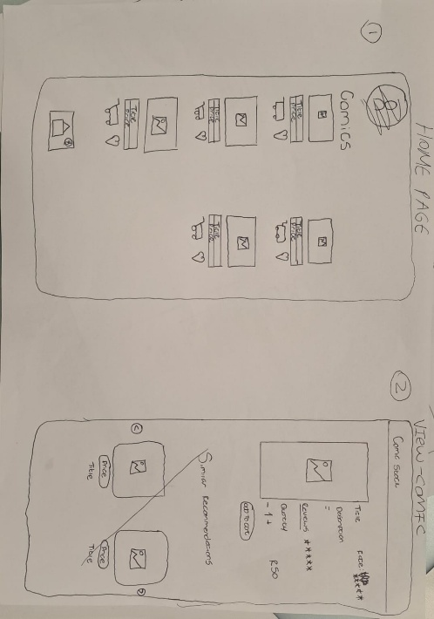
Page 2-3 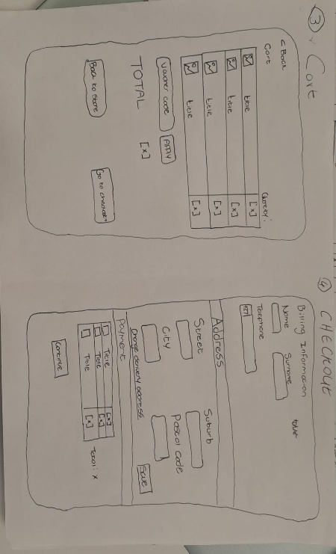
Page 3-4
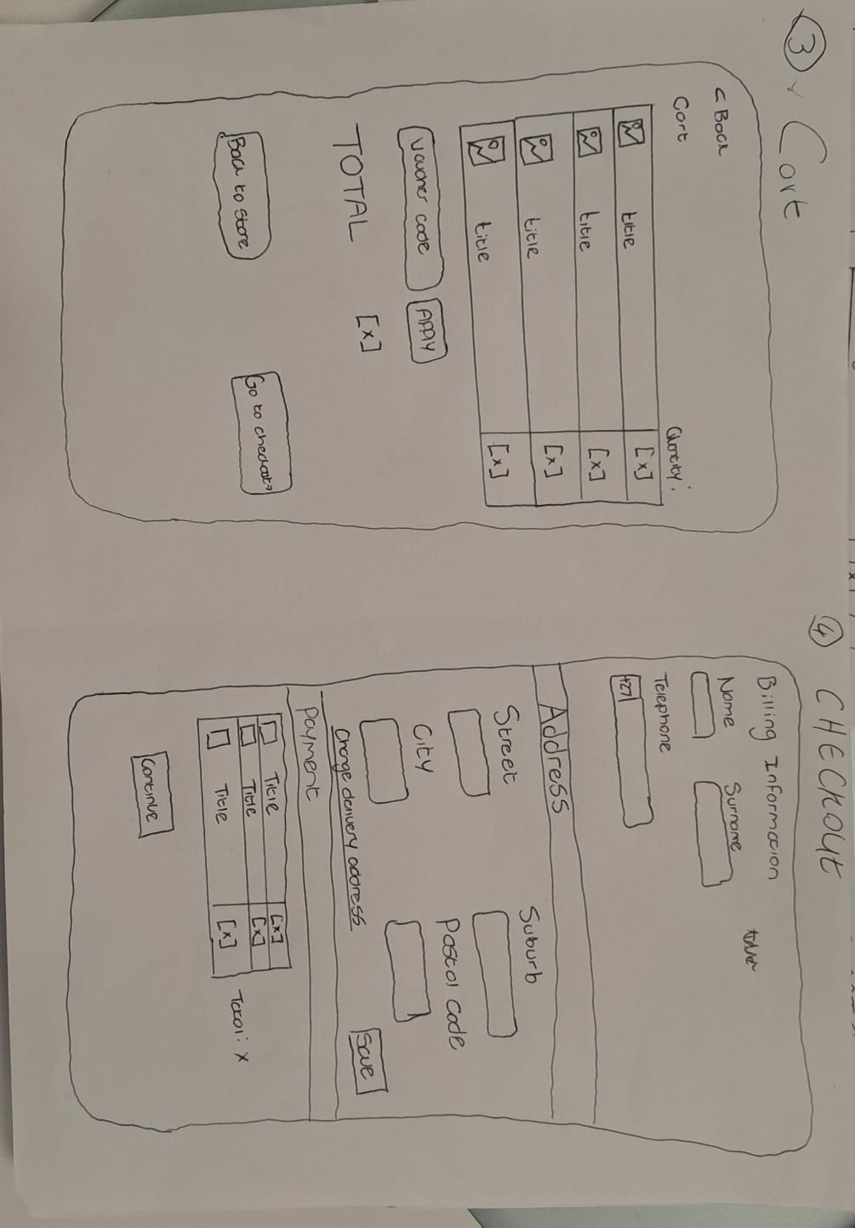
Page 5-6
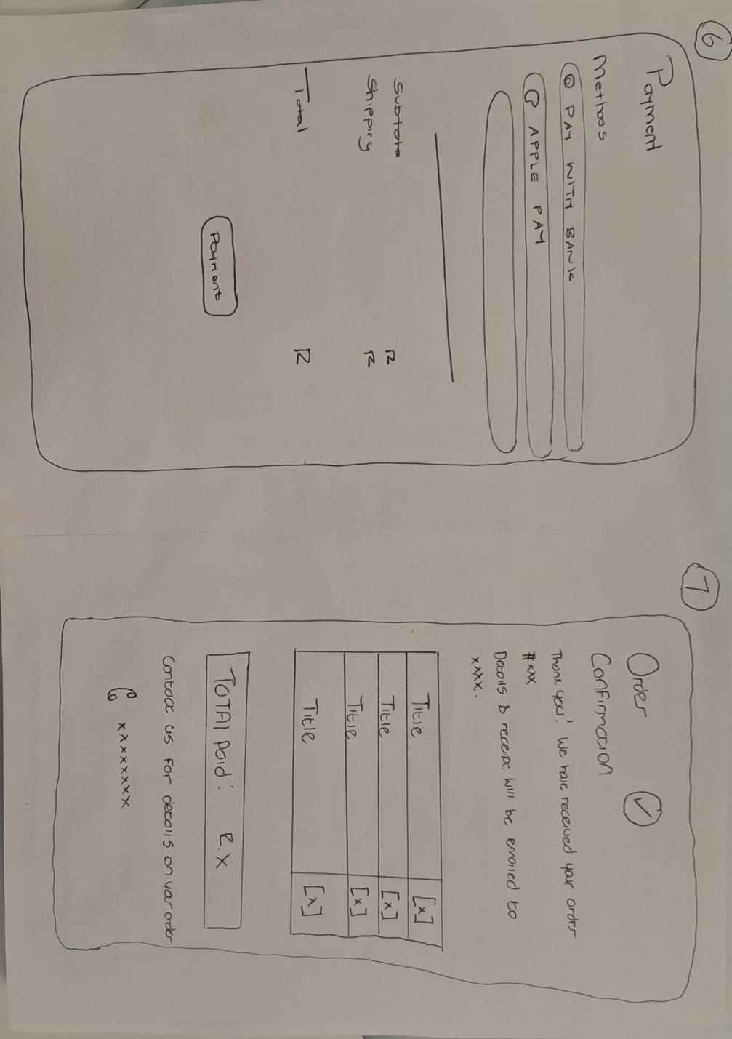
(please note the discrepancy on the in picture number 6-7 should be rather 5-6)

SAMPLE OF USERS WE SPOKE TO
- 2 Technical users
- 3 End Users
Feedback and amendments to our initial mockups
We took our design to the real world, measuring its performance by collecting real time feedback from potential future users. We interacted with five users, asking each of them to attempt to purchase a comic book without our input. Four of the five were able to successfully complete the purchase as intended, while the failed attempt was a consequence of the user being unable to identify our “Cart” button on the home page. In addition to this task, we asked our users if they would describe the current design as “easy”, “intuitive”, or “frictionless” to use?
In this case, only three of the five users were able to affirm these descriptions. Finally, we asked the users to supply us with any other feedback they felt appropriate or necessary to create a more user-friendly experience on the mobile application.
Below we provide the aggregate feedback:
- The “Cart” icon needs to be identifiable.
- Improve the alignment of elements of the screen making them intuitive to use.
- Make consistent design choices across the distinct pages included in the purchase process. For example, headers should occur consistently across the relevant pages, and all instances of the “add items to cart” button should have the same design.
- Functionality needs to be added to increase or decrease the quantity of a particular item from the “Cart” screen.
- Delivery details should ideally be entered once in the user’s profile and loaded at checkout, as opposed to being entered right before payment.
- Reduce redundancy of information across separate screens. The same selected items for purchase are shown on screens 3, 4, and 7.
- Simplify the payment confirmation screen to a simple message and/or graphic and communicate a detailed description of the order over email.
- Include the VAT amount right before purchase. This is a legal requirement.
- Add short descriptions under each comic book element on the home page.
- Make it clearer that the comic book elements on the home page are clickable with use of a boarder.

FINAL DESIGN INFORMED BY USER FEEDBACK
The final design for this phase of development integrates all this feedback and can be found in a digital format here on Miro our design and collaboration platform.

Please feel free to contact below for any questions or clarification.
banele.mkhize@entelect.co.za liam.abbot@entelect.co.za

